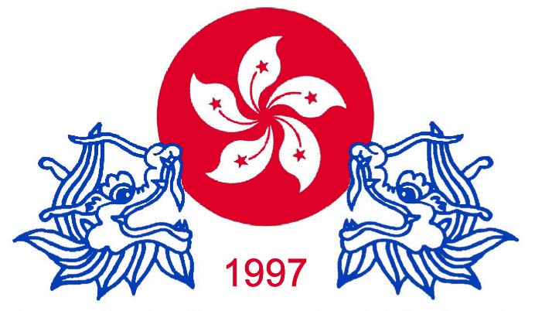
中國香港特別行政區龍舟聯會
China Hong Kong Special Administrative Region Dragon Boat Federation
港新界深井碧堤半島第八座38樓C室 / Tel : 68213948
Flat C 38/F Tower 8 Bellagio Sham Tseng NT HK / Fax : 2358 1282 Affiliate Festival
中國秘書處 : 廣州市越秀區解放南路123號26樓 / 86 - 13610277265
chksardbf97@gmail.com
Invitation 10 February, 2017 .
2017 China 4 City International Dragon Boat Festival
Dear All Dragon Boat Federation , Association , Club , Teams President, Teams Manager
On behalf of CHKSARDBF and CHINA Jiangsu Nantong City , Jiangsu Xhuzhou , Guiyang Kai Li City , Guangzhou City International Dragon Boat Festival Organizing Committee . I am taking this opportunity of inform
all of you that the China Hong Kong SAR Dragon Boat Federation .

We have just finalized preparation for the said festival and invitation with events particulars Are expected
to be sent out early month .

I shall be most grateful if you could assist us in circulating this information to your fellow members of
and insert the info in your website and also publish it in your forth coming new letter and update .

We feel grateful for your never ending kind support in our dragon boat festival and we love to recommend
you and your team in China 4 City 27 May – 12 June - 2017 International Dragon Boat year festival .

Do feet free to contact me should you need any further info or assistance . Please help us to forward to other
dragon boat Association and Club .

2017 CHINA Four City International Dragon Boat Festival as follow :

1. Nantong City from 27 to 31 May , 2017 Races in 500M / 7 KM International Man open ,
Women open . Jiangsu Nantong City 23 crew Boat . ( have money prize award )
2. Xhuzhou City from 31 May to 04 June 2017. Races in 500m and 800m International Man's open and
Women open 23 crew boat . ( have money prize award )
3. Gui Yang Kai Li City , from 04 to 07 June , 2017. Races in 300m and 500m International Man's open and
Women open 22 crew boat . Kai Li City was a Ethnic Minority city . ( have money prize award )
4. Guangzhou City from 07 – 12 June 2017 Races 600 M 22 crew Boat International Man open ,
Women open .
Hosted each team accommodation , meal and local transport for 28 people ( 20 paddlers ,1 drummer ,
1 steersmen , 1 gongmen , 3 reserve and 2 official ) .
The invitation teams a request flight to Shang Shi Pudong Airport on 27 May our liaison officer and vehicles will
meeting your teams .

Request :

1. Arrival in 27 May 2017 .Shang Shi Pudong will arrange meet your teams . and departure on 12 June
Guangzhou airport flight information for us . Request Arrival and Departure flight information .
2. One passport size photo with name in back and passport copy for buy train ticket in CHINA .
3. Request your teams insurance Copy .
4. 10 minutes cultural in nature presentation optional in celebration dinner
dress in informal but dress smartly ( preferably in team uniform ) .
5. Teams history , list , photo before 15 March , 2017 . By post and e-mail send to Andrew Chan ( Flat C , 38/F,
Tower 8 , BELLAGIO , Sham Tseng, N.T. Hong Kong )
6. All invitation teams please confirm before 15 March , 2017.
7. We request all oversea teams concentrate in Shang Shi Pudong airport on 27 –May , 2017 .
Contact : Andrew CHAN Flat C , 38/F , Tower 8 , BELLAGIO , Sham Tseng , N.T. Hong Kong .
e-mail chksardbf97@gmail.com / chksardbf97@yahoo.com.hk
Tel : (HK) 852 – 68213948 / 86 - 13610277265
中國秘書處 : 廣州市越秀區解放南路123號26樓
(China) 86 – 13610277265

Your great assistance and support is truly appreciated .

Best regards,

Andrew CHAN 陳鏡清 主席
Chairman of The World Dragon Boat League Organizing Committee
of the Universal Chinese Sports Association
Chairman of China Hong Kong Special Administrative Region Dragon Boat Federation
Vice Director of China 4 City International Dragon Boat Organizing Committee

